**CMP510 (AR and VR Technologies) Assignment**



**Navrachana University**

Team Members:

* Naitik Dholakiya (22000255)
* Pooja Purohit (22000262)

Project Title: AR Jewelry

**Description of project:**

Imagine being able to try on beautiful jewelry without even stepping into a store! This AR Jewelry Showcase brings four stunning pieces—a necklace, Crown, Nosepin, and earrings—right to your mobile screen. Using augmented reality, you can see each piece in your own space and even try it on virtually to see how it looks on you. Realistic lighting and reflections make each piece shine, creating an experience that feels almost like the real thing.

**Features: -**

**Virtual Try-On**

* "Wear" each jewelry piece in AR to see how it looks on you, giving a realistic preview of necklaces, nose pin, Crown, and earrings.

**Realistic Lighting & Reflections**

* High-quality lighting effects and reflections make the jewelry shine as if it were in natural light, enhancing realism.

**Screenshot & Share**

* Capture snapshots of the jewelry on you or in your space, and easily share these previews with friends for opinions.

**Asset Details**

* 1. Necklace: - Self Made

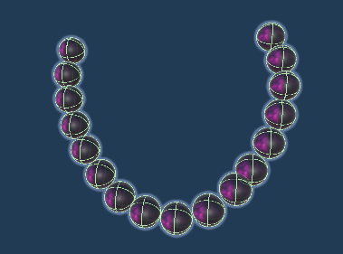

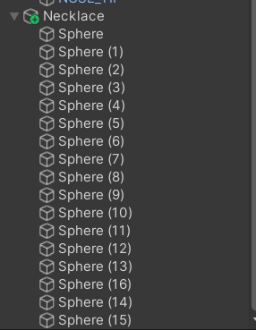

* 2. Form SketchFab :- <https://skfb.ly/6vxMG>
* 3. From SketchFab :- <https://skfb.ly/onZUR> (Crown 1 has been used)
* 4. Form SketchFab :- <https://skfb.ly/6ZvFx>

**Steps: -**

**Scene 1: Main Menu (Start and Quit)**

1. Create a New Scene named "Menu."

2. Add a Canvas to the scene.

- Right-click in the Hierarchy, go to UI > Canvas.

3. Add Two Buttons on the Canvas.

- Right-click the Canvas, go to UI > Button, and create two buttons.

- Name one button "Start" and the other "Quit".

4. Set Up Button Texts by selecting each button and modifying the Text component to say "Start" and "Quit."

5. Add Button Functionality to button.

- For the "Start" button: create a script that loads the second scene (Jewelry Menu) on click.

**Scene 2: Jewelry Menu (Jewelry Display and Try Me Button)**

1. Create a New Scene named "Item Selection."

2. Add a Canvas for displaying the jewelry options.

3. Add Jewelry Images to the Canvas.

- Add images of each jewelry piece beside the buttons for a visual reference.

4. Add a "Try Me" Button for each jewelry piece.

- Under each jewelry button, add a "Try Me" button. Each "Try Me" button will link to the respective AR scene.

5. Add Button Functionality to each "Try Me" button to load the specific AR scene for each jewelry piece.

**Scene 3: AR Scene (Display Selected Jewelry in AR)**

1. Create a New Scene for each jewelry piece in AR (e.g., "Necklace," "Crown," etc.).

2. Set Up AR Session and XR Origin for AR functionality.

- Import AR Foundation and ARCore.

- In the scene, add an *AR Session* and an *XR Origin* (or AR Camera) to initialize the AR experience.

3. Add a Canvas with a Back Button to return to the Jewelry Menu.

- Create a new Canvas in the scene.

- Add a "Back to Main Menu" button on this Canvas and set it to load the Jewelry Menu scene.

4. Place Jewelry Model in AR Scene

- Import the 3D model for the selected jewelry piece (e.g., necklace, Crown).

- Position the model in front of the AR camera to display it in the user’s environment.

5. Repeat for Each Jewelry Piece

- Duplicate the AR scene for each jewelry item (e.g., one scene for Necklace, another for Crown) and repeat the setup.

**SCRIPTS: -**

1.Scene Changing script

CODE: -

using UnityEngine;

using UnityEngine.SceneManagement;

using UnityEngine.UI;

public class Start_home : MonoBehaviour

{

    // Use a string to store the scene name for flexibility

    public string sceneName;

    void Start()

    {

        Button button = GetComponent<Button>();

        button.onClick.AddListener(OnStartButtonClicked);

    }

    public void OnStartButtonClicked()

    {

        if (!string.IsNullOrEmpty(sceneName))

        {

            SceneManager.LoadScene(sceneName);

        }

        else

        {

            Debug.LogError("Scene name is not set.");

        }

    }

}

**Conclusion: -**

The AR Jewelry Showcase project is a fun and engaging way for users to explore beautiful jewelry pieces virtually. With an easy-to-navigate setup—starting from the main menu, moving through a selection of jewelry items, and finally into AR for a “try-on” experience—users get a realistic feel for each piece without needing to visit a store. This setup not only makes virtual shopping more interactive but also brings jewelry to life in a unique way, highlighting how AR can transform the shopping experience and create a real connection between users and products.

**System Requirements:**

Android: 12 or higher

Memory: 1gb or more.

**Plagiarism Report: -**

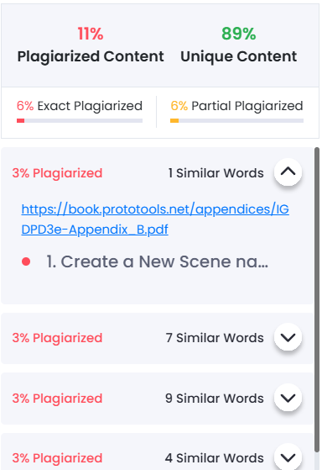

**Screenshots: -**

All the Scene Screenshot

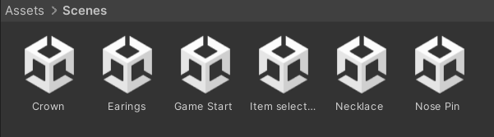

The Prefabs

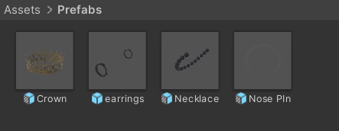

Images

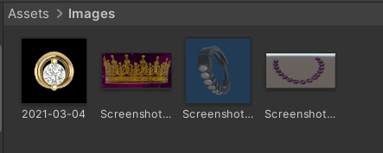

All Prefab Internals

1.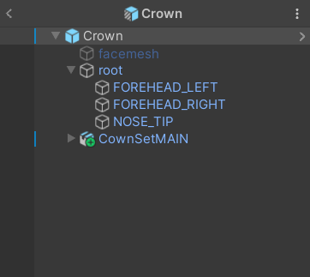

2. 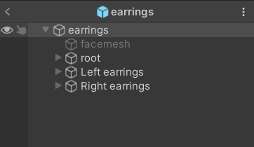

3. 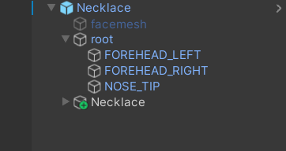

4. 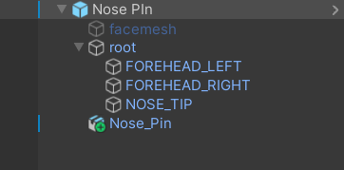

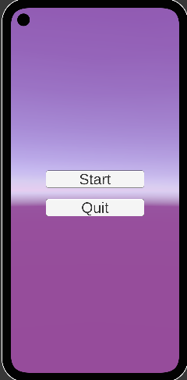 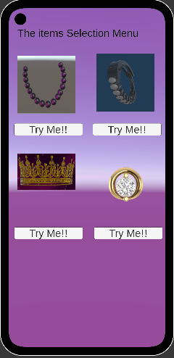

Assets Lists: -

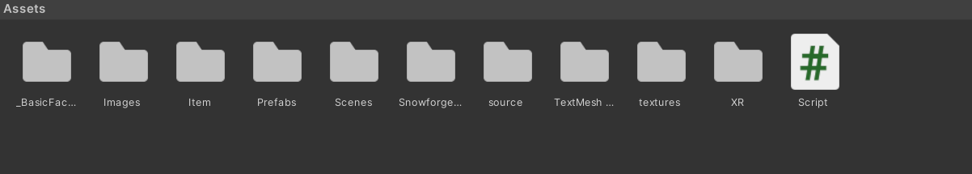

Filter Use: -

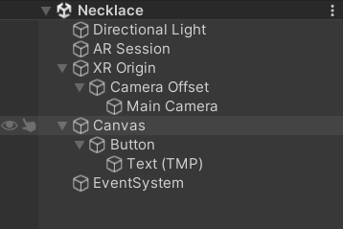

AR Session: -

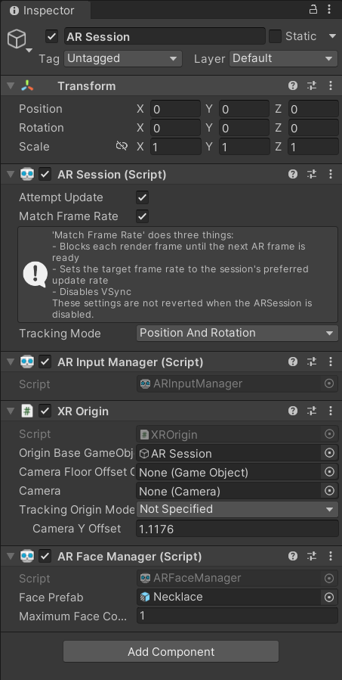

Main Camera of XR Origin: -

